Unbundled Local Loop - 2-Wire or 4-Wire Analog (Voice Grade) Loop – V32.0

History Log (Link blue text to: “Replace Existing Download Unbundled Local Loop – 2-Wire or 4-Wire Analog (Voice Grade) Loop History Log)

Product Description

Unbundled Local Loop – 2-Wire or 4-Wire Analog (Voice Grade) Loop is a voice frequency transmission path that provides a connection from the CenturyLink™ Central Office (CO) Distribution Frame, or equivalent, to the loop demarcation point at end-user’s premises. Analog loops are available as voice grade, point-to-point configurations suitable for local exchange service.
2-Wire or 4-Wire Analog (Voice Grade) Loops are further defined as:

- 2-Wire analog interfaces supporting loop start signaling
- 2-Wire analog interfaces supporting ground-start signaling
- 2-Wire analog interfaces supporting reverse battery with loop closure by end-user
- 2-Wire analog interfaces supporting reverse battery by end-user
- 2-Wire analog interfaces with no signaling functions provided by CenturyLink
- 4-Wire analog interfaces with no signaling functions provided by CenturyLink. The associated transmission channel will use separate transmit and receive paths.

General information regarding Unbundled Local Loop products is located in Unbundled Local Loop – General Information. (Link blue text to: http://www.centurylink.com/wholesale/pcat/unloop.html)

Product Diagram

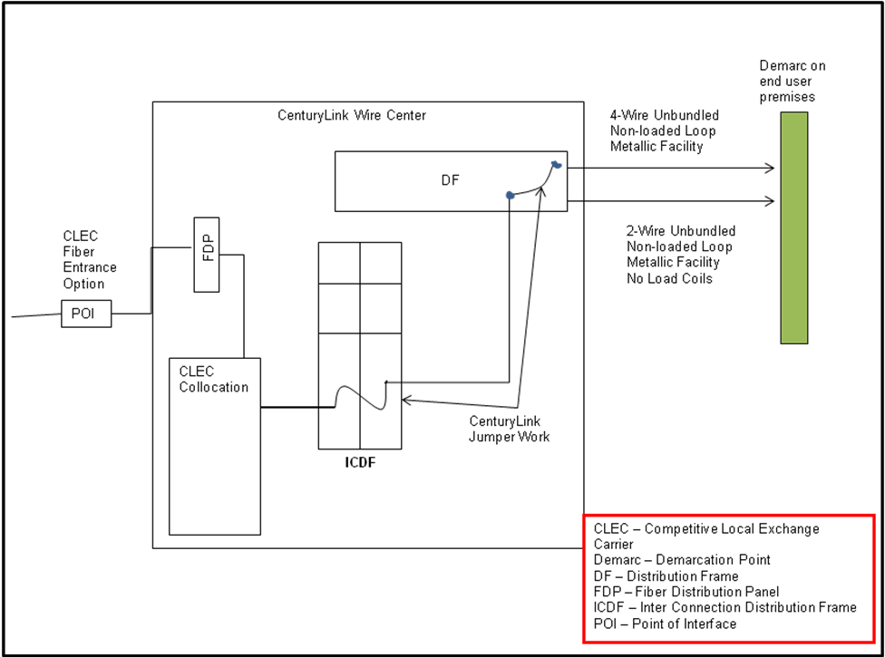

Availability
2-Wire or 4-Wire Analog (Voice Grade) Loop is available where facilities exist throughout CenturyLink QC. (Link blue text to: http://www.centurylink.com/wholesale/pcat/territory.html)
If the request involves a 2-Wire or 4-Wire Analog (Voice Grade) Loop, and the loop is considered to be the primary service, CenturyLink will construct facilities to satisfy the primary lines for Unbundled Local Loop as CenturyLink constructs these facilities for its own end-users. Additional information on Unbundled Local Loop build requirements is available in the Availability section of Unbundled Local Loop - General Information. (Link blue text to: http://www.centurylink.com/wholesale/pcat/unloop.html)

Terms and Conditions
General Interconnection Agreement, regulation and policy information for 2-Wire or 4-Wire Analog (Voice Grade) Loop is located in the Terms and Conditions section of Unbundled Local Loop – General Information. (Link blue text to: http://www.centurylink.com/wholesale/pcat/unloop.html#prod)

Technical Publications
Technical characteristics, including Network Channel/Network Channel Interface (NC/NCI™) codes, and available interfaces are described in Technical Publication, Interconnection – Unbundled Loop, 77834. (Link blue text to: http://www.centurylink.com/techpub/77384/77384.pdf)

Pricing

Rate Structure
Recurring charges are comprised of the following rate elements:
- 2-Wire or 4-Wire Analog (Voice Grade) Loop
- Interconnection Tie Pair (ITP), per connection (two ITP for 4-Wire)

Recurring charges are billed on a month-to-month basis. Nonrecurring charges depend on the Installation option chosen. Nonrecurring charges are billed at the time service is rendered. A nonrecurring charge applies to the installation of service(s) and in some states a disconnect service(s) charge will apply.
Additional rate element information is located in the Pricing section of Unbundled Local Loop - General Information. (Link blue text to: http://www.centurylink.com/wholesale/pcat/unloop.html#pri)

Rates
Rates are available in Exhibit A or the specific rate sheet in your Interconnection Agreement. If there are elements that are not in your Interconnection Agreement, contact your CenturyLink Service Manager. (Link blue text to: http://www.centurylink.com/wholesale/clecs/accountmanagers.html)

Tariffs, Regulations, and Policies
Tariffs, regulations and policies are located in the state specific Tariffs/Catalogs/Price Lists. (Link blue text to: http://www.centurylink.com/Pages/AboutUs/Legal/Tariffs/displayTariffLandingPage.html)

Optional Features
Optional Features section does not apply to 2-Wire or 4-Wire Analog (Voice Grade) Loop.

Features / Benefits

Features | Benefits
Market Presence | - Allows you to provide Local Exchange Telephone Service to your end-users
Low Costs | - Minimizes the investment in your network  - Ability to lease facilities from CenturyLink at wholesale rates

Applications
See Features/Benefits.

Implementation

Product Prerequisites
If you are a new Competitive Local Exchange Carrier (CLEC) and are ready to do business with CenturyLink, view Getting Started for Facility-Based CLECs. (Link blue text to: http://www.centurylink.com/wholesale/clecs/clec_index.html) If you are an existing CLEC wishing to amend your Interconnection Agreement or New Customer Questionnaire, additional information is located in the Interconnection Agreement. (Link blue text to: http://www.centurylink.com/wholesale/clecs/negotiations.html)

Pre-Ordering
General pre-ordering activities are described in the Pre-Ordering Overview. (Link blue text to: http://www.centurylink.com/wholesale/clecs/preordering.html)
The Interconnect Mediated Access (IMA) User’s Guide specifically details information applicable to pre-ordering functions. (Link blue text to: http://www.centurylink.com/wholesale/ima/gui/imauser.html)
Loop Qualification
CenturyLink strongly recommends use of pre-ordering functionality to assist in achieving increased service request flow through and accuracy that will result in reduced service request rejects.
The following activities may need to be performed by you in preparation for the issuance of a service request:
- Validate address
- Check facility availability
- Validate Carrier Facility Assignment (CFA)
- Review Customer Service Record (CSR)
- Query Raw Loop Data (RLD)
- Convert Plain Old Telephone Service (POTS) to Unbundled Loop Tool
For more information go to the Pre-Ordering section of Unbundled Local Loop – General Information (Link blue text to: http://www.centurylink.com/wholesale/pcat/unloop.html) or see the Loop Qualification and Raw Loop Data - CLEC Job Aid. (Link blue text to: http://www.centurylink.com/wholesale/training/desc_loopqualjobaid.html)
These activities will enable you to verify the type of facility and the loop make-up of the Unbundled Local Loop, which will assist you in identifying the appropriate service request intervals located in the Service Interval Guide (SIG). (Link blue text to: http://www.centurylink.com/wholesale/guides/sig/index.html)
For additional pre-ordering information refer to the Pre-Ordering section of the Unbundled Local Loop - General Information. (Link blue text to: http://www.centurylink.com/wholesale/pcat/unloop.html#preorder)

Ordering
General ordering activities are described in the Ordering Overview (Link blue text to: http://centurylink.com/wholesale/clecs/ordering.html) and in the Ordering section of Unbundled Local Loop - General Information. (Link blue text to: http://www.centurylink.com/wholesale/pcat/unloop.html#order)
Analog Specific LSOG entries are attributed to the following functions:
Analog Loop
The ACT field of the LSR must show a ‘V’ for ‘conversion as is’ or a ‘Z’ for ‘conversion as specified with listing’, and REQTYP of ‘AB’.
When ordering a new request for 2-Wire or 4-Wire Analog (Voice Grade) Loop, the ACT field of the LSR must show an ‘N’ for New Service, and REQTYP of ‘AB’.
For other valid ACT type or other information regarding the LSR entries refer to Unbundled Local Loop - General Information. (Link blue text to: http://www.centurylink.com/wholesale/pcat/unloop.html)
LNP
2-Wire or 4-Wire Analog (Voice Grade) Loops may also be requested in conjunction with LNP. When combining the 2-Wire or 4-Wire Analog (Voice Grade) Loops with LNP, the requests are processed following the Unbundled Loop Installations Options and Service Intervals. 2-Wire or 4-Wire Analog (Voice Grade) Loops with LNP include the lift and lay with LNP functions. For more information refer to LNP. (Link blue text to: http://www.centurylink.com/wholesale/pcat/lnp.html)
Unbundled Local Loop - 2-Wire or 4-Wire Analog (Voice Grade) Quick Loop without LNP provides you with a reduced provisioning interval for conversion of an existing service to Unbundled Local Loop, which is a basic lift and lay installation. No other functions will be performed with Quick Loop without LNP. Quick Loop circuits quantities and ordering intervals are outlined in the Quick Loop section of the SIG.
Unbundled Local Loop - 2-Wire or 4-Wire Analog (Voice Grade) Quick Loop with LNP provides you with a reduced provisioning interval for conversion of an existing service to Unbundled Local Loop, which is a basic lift and lay installation with the LNP function. Quick Loop with LNP circuit quantities and service request intervals are outlined in the Quick Loop with LNP section of the SIG.
If the request involves LNP the ACT field must show a ‘V’ for ‘conversion as specified’, and REQTYP of ‘BB’.
Quick Loop
When submitting a service request, you are responsible for identifying whether the 2-Wire or 4-Wire Analog (Voice Grade) Loop is eligible for Quick Loop with LNP. If the Desired Due Date (DDD) specified is less than the standard interval, your request will be processed with intervals found in the SIG. If your DDD is greater than or equal to the standard interval, the requested DDD will be assigned. For specific information regarding your DDD refer to Unbundled Local Loop - General Information. (Link blue text to: http://www.centurylink.com/wholesale/pcat/unloop.html)
Following are the NC/NCI codes eligible for Quick Loop. For additional NC/NCI codes refer to Technical Publication, Interconnection - Unbundled Loop, 77384. (Link blue text to: http://www.centurylink.com/techpub/77384/77384.pdf)
If the NC Code is | Then Available NCI Codes Are
If the NC Code is | CenturyLink CO-NI  NCI | End-User EU-NI  (SEC) NCI
LX-- | 02QC3.OOD | 02LS2
 | 02QC3.OOB | 02GS2
 | 02QC2.OOF | 02NO2
 | 04QC2.OOF | 04NO2
 | 02QC3.RVT | 02RV2.O
 | 02QC3.RVO | 02RV2.T
For a 2-Wire or 4-Wire Analog (Voice Grade) Loop conversion request
Quick Loop with LNP
For a 2-Wire or 4-Wire Analog (Voice Grade) Loop to qualify for Quick Loop with LNP, the following information is required on the LSR:
- The ACT field must show a ‘V’ for ‘conversion as is’ and REQTYP of ‘BB’.
- The CHC field must show ‘N’ or blank.
- The TEST field must show ‘N’ or blank.
- The LSR must show the NC/NCI codes.
Unbundled Local Loop - 2-Wire or 4-Wire Analog (Voice Grade) Loops may also be requested in conjunction with LNP. When combining the 2-Wire or 4-Wire Analog (Voice Grade) Loops with LNP, the requests are processed following the Unbundled Loop Installations Options and Service Intervals. 2-Wire or 4-Wire Analog (Voice Grade) Loops with LNP include the lift and lay with LNP functions. Refer to LNP for additional information. (Link blue text to: http://www.centurylink.com/wholesale/pcat/lnp.html)

Unbundled Local Loop Installation Options
Six installation options are available for Unbundled Local Loop. Detailed information about the different installation options is located in the Ordering section of Unbundled Local Loop – General Information. (Link blue text to: http://www.centurylink.com/wholesale/pcat/unloop.html#order)

Circuit ID (ECCKT)
Unbundled Local Loops are assigned with Circuit Identification numbers. Detailed information about the Circuit Identification number format is located in the Ordering section of Unbundled Local Loop - General Information. (Link blue text to: http://www.centurylink.com/wholesale/pcat/unloop.html#order)

Required Forms and LSR Activity Types
Unbundled Local Loop - 2-Wire or 4-Wire Analog (Voice Grade) Loop service requests are submitted using the following Local Service Ordering Guidelines (LSOG) forms:
- Local Service Request (LSR)
- End User (EU)
- Loop Service (LS)
- Loop Service with Number Portability (LSNP), if applicable
- Directory Listing (DL), if applicable
Field entry requirements are described in the LSOG. (Link blue text to: http://www.centurylink.com/wholesale/clecs/lsog.html) Some UBL specific information, including valid LSR ACT types, is described in the Ordering section of Unbundled Local Loop - General Information. (Link blue text to: http://www.centurylink.com/wholesale/pcat/unloop.html#order)
Service requests are placed using IMA Extensible Markup Language (XML), (Link blue text to: http://www.centurylink.com/wholesale/ima/xml/index.html), IMA Graphical User Interface (GUI), (Link blue text to: http://www.centurylink.com/wholesale/ima/gui/index.html) or faxed to (888) 796-9089.
Design Layout Report (DLR) requests are described in the IMA XML Network Disclosure Document (Link blue text to: http://www.centurylink.com/disclosures/netdisclosure409.html) and in the IMA User’s Guide. (Link blue text to: http://www.centurylink.com/wholesale/ima/gui/imauser.html)
Service interval guidelines are found in the Service Interval Guide (SIG). (Link blue text to: http://www.centurylink.com/wholesale/guides/sig/index.html)
Information about project requests and handling is located in Unbundled Local Loop - General Information. (Link blue text to: http://www.centurylink.com/wholesale/pcat/unloop.html)

Provisioning and Installation
General provisioning and installation activities are described in the Provisioning and Installation Overview (Link blue text to: http://centurylink.com/wholesale/clecs/provisioning.html) and the Provisioning and Installation section of Unbundled Local Loop – General Information. (Link blue text to: http://www.centurylink.com/wholesale/pcat/unloop.html#order)
A jeopardy occurs on a service request if a condition exists that threatens timely completion. Jeopardy notifications are described in Provisioning and Installation Overview. (Link blue text to: http://www.centurylink.com/wholesale/clecs/provisioning.html)

No Dial Tone
Conversion or Change request with new CFA: CenturyLink verifies for dial tone at your CFA 48 hours after CenturyLink’s APP (application) date. If CenturyLink finds No Dial Tone (NDT), CenturyLink will retest 48 hours prior to due date. If dial tone is still not present, CenturyLink will email the NDT results to you through CenturyLink’s Provider Test Access (PTA) email system. You will receive the NDT PTA email notification approximately 24 to 36 hours prior to the due date. CenturyLink will email only when there is No Dial Tone. You will need to supply the dial tone by the due date or supplement the service request, changing the due date.
To receive the NDT results, you must provide one permanent email. This email address can not be the same as the PTA Test results email address. To provide your NDT PTA email address, contact your CenturyLink Service Manager. (Link blue text to: http://www.centurylink.com/wholesale/clecs/accountmanagers.html) It is necessary to notify your CenturyLink Service Manager with any email address changes.
Following are the NC/NCI codes for which the 48 hour dial tone verification applies:

If the NC Code is | Then Available NCI Codes Are
If the NC Code is | CenturyLink  CO-NI  NCI | End-User  EU-NI  (Sec) NCI
LX-- | 02QC3.OOD | 02LS2
 | 02QC3.OOB | 02GS2

Coordinated Installation information is located in the Ordering section of Unbundled Local Loop – General Information. (Link blue text to: http://www.centurylink.com/wholesale/pcat/unloop.html#order)
For CLECS enrolled in the NDT PTA notification the following applies:
Coordinated Installation requests on an existing 2-Wire or 4-Wire Analog (Voice Grade) Loop: If CenturyLink fails to email the NDT PTA notification 24 hours prior to the due date, CenturyLink will not require a supplement to the service request with a new due date. CenturyLink will attempt to reschedule at a mutually agreed upon time for the same day. CenturyLink will contact the Implementation Contact (IMPCON) to reschedule. If rescheduling for the same day is not possible, this will result in a CenturyLink Jeopardy.
If CenturyLink sent the NDT PTA notification 24 hours prior to the due date and rescheduling is not workable by you or CenturyLink for the same day, the service request will be coded as a customer not ready jeopardy. A supplement to your service request will be required. Jeopardy notifications are described in Provisioning and Installation Overview. (Link blue text to: http://www.centurylink.com/wholesale/clecs/provisioning.html)
If dial tone is found 48 hours before the due date, then if 1 hour before the appointment time the dial tone is no longer present, CenturyLink will contact the IMPCON for resolution. If you are not ready at the appointment time, a supplement to the service request is required.
Click here for an example of a No Dial Tone PTA notification. (Link to: No Dial Tone PTA.doc)

Testing
Performance testing available on 2-Wire or 4-Wire Analog Voice Grade) Loops includes:
- Opens, Grounds, Shorts, Noise, or Foreign Volts
- Insertion Loss at 1004 Hertz (Hz)
- Attenuation Distortion
- Automatic Number Identification (ANI) when dial-tone is present prior to conversion of a CenturyLink circuit to a CLEC circuit.
Transmission performance parameters and limits are available in Technical Publication, Interconnection – Unbundled Loops, 77384. (Link blue text to: http://www.centurylink.com/techpub/77384/77384.pdf)
Hours of Operation
Installation hours are described in the Provisioning and Installation section of Unbundled Local Loop – General Information. (Link italicized text to: http://www.centurylink.com/wholesale/pcat/unloop.html#pro)

Maintenance and Repair
General maintenance and repair activities are described in the Maintenance and Repair Overview. (Link blue text to: http://www.centurylink.com/wholesale/clecs/maintenance.html)

Billing
Customer Records and Information System (CRIS) billing is described in Billing Information – Customer Records and Information System (CRIS). (Link blue text to: http://centurylink.com/wholesale/clecs/cris.html)
Loss and Completion Reports are generated based on loss and gain account activity. Completion notification, including Loss and Completion Reports, is described in Billing Information – Additional Outputs – SMDR, Completion Report, Loss Report. (Link blue text to: http://www.centurylink.com/wholesale/clecs/output.html)

Training
View CenturyLink courses by clicking on Course Catalog. (Link blue text to http://www.centurylink.com/wholesale/training/coursecatalog.html)

Contacts
CenturyLink contact information is located in Wholesale Customer Contacts. (Link blue text to: http://www.centurylink.com/wholesale/clecs/customercontacts.html)

Frequently Asked Questions (FAQs)
This section is currently being compiled based on your feedback.

Last Update: April 9, 2015

NC/NCI™ is a trademark of Telcordia Technologies, Inc.
META Tags: Unbundled Analog Loop, Unbundled Voice Grade Circuit, Loop, Unbundled Circuit, Analog Circuit, Unbundled Local Loop, Unbundled Loop, Quick Loop, LX—

